Acorn Class – Autumn 1 – Parent overview
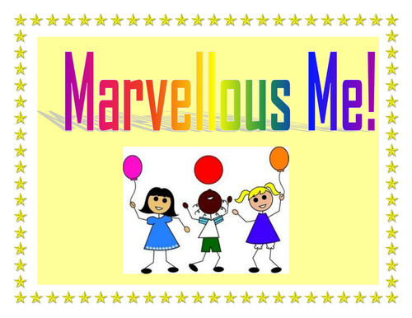
Marvellous Me!

This half term we will be focusing on everything to do with ourselves. Each week we will have a different focus. We will be looking at ourselves and what we look like, what makes us special. We will look at our homes and families as well as looking at how we stay healthy. The children will be learning the story of ‘The Three Little Pigs’ and having a go at making different homes, retelling the story and talking about the different characters. We will have a look at numbers and how they are all around us (door numbers, birthday cards, prices in shops etc.). As the children settle we will establish our daily routine and what a day in nursery looks like. We will also be playing lots of games and singing songs as we get to know each other and make friends. The children will spend lots of time inside and outside the classroom getting used to their environment.
Sparkly Starter | Fab Finish
To begin our project, we have a range of different activities including making junk model houses, making a self portrait, making faces using loose parts and learning and performing; Heads, shoulders, knees and toes. | At the end of the project, we’ll be making a photo frame to display a picture of our family. If you could email a family photo to nursery20@oakhurstfirst.com then we can print a photo ready to go in the frame to take home.
Date: w.b. Monday 14th September | Date: w.b. Monday 19th October

Key topic vocabulary
Below is a list of key vocabulary for your child to know and understand for the topic organised into 3 tiers, ‘must know’, ‘should know’ and ‘could know’.
Tier 1 – Must | Tier 2 – Should | Tier 3 - Could
- Mummy  - Daddy  - Me  - House  - Nursery | - Body parts (arm, head, leg etc.)  - Brother  - Sister  - Family  - He/ She  - School | - Home  - Brick / straw/ sticks  - Body  - Birthday  - Same  - Different

How you can help at home:
- Support children completing the take away task (Please ensure it is the children’s work)
- Share a story with your child as often as possible. The children will start to bring home a book with them with a book you can record when they have read it, what they enjoyed, did they join in, etc. They can read the school book or any book they enjoy reading at home.
- Find numbers around the house, when you go on walks etc. Talk to the children about the numbers. (E.g. We have a number 10 on our door.)

Take away task – Choose one or more to complete at home! Please take photos and email us – nursery20@oakhurstfirst.com or post on Tapestry.
Please don’t bring anything into school).
Due w.b: 28.9.20

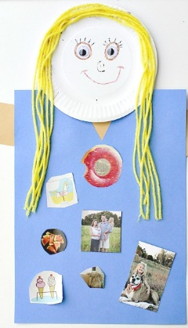
Create a collage all about you! You could include drawings/ pictures/ photos about things you like/ dislike.

You could draw/ paint/ make a picture of your house. Can you count how many windows you need? How many doors? What number goes on the front?
