Steps to success:
Must | Should | Could
Change the character and setting | Be able to retell the story including new innovations | Record exciting adjectives and vocabulary you wish to use in your story

Tiddlers Adventure  Characters and setting | Innovation  Characters and setting
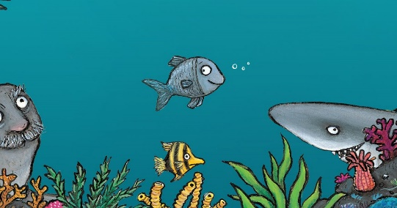
Tiddler in the ocean
Tiddlers Adventure | Innovation
beginning

Build up

Problem

Resolution

Ending

