Welcome to Pine Class home learning!

Hope you had a fantastic weekend!
Remember to upload any wonderful work onto Tapestry or you can email it to us – pineclass@oakhurstfirst.com
All the best Mrs Stirk, Mrs Griffin and Mrs Kaye

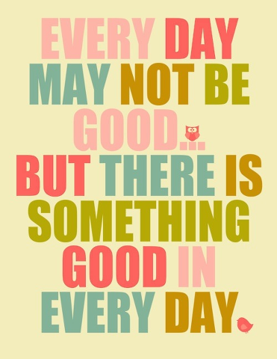

Be Active!
Start the day being active. Have a go doing any of the following…
- Move and Freeze - https://youtu.be/388Q44ReOWE

- Disney dance – https://youtu.be/SH-7A3NVQbY

- Andy’s Wild Workouts on CBeebies iPlayer

- Kids home exercise – https://youtu.be/L-8wW40jTzc

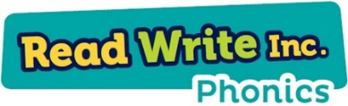
Phonics

Please could you read your Read Write Inc PowerPoint/ditty sheet, read through the speed sounds, green words and red words on the first few slides of each PowerPoint or top of ditty sheet, then read through the book or sheet. After you have read through the story you can:
*Ask the children questions about the story.
* Choose a sentence or word from the story and get them to write it
* Practise writing/spelling any of the green or red words

https://www.youtube.com/watch?v=p7hRbrpq5Bo – watch for set 2 sounds.
https://www.youtube.com/watch?v=zeiQZGRo28w&list=RDCMUCo7fbLgY2oA_cFCIg9GdxtQ&index=4 – Fred Talk

- Write some red and green words (from the ditties or books they have been reading) on pieces of paper and hide around your home. See how many your child can find.
- Can they write a few sentences using any of these words.

http://www.tarvin.cheshire.sch.uk/serve_file/164219
Focus on set 1 and for extension set 2.

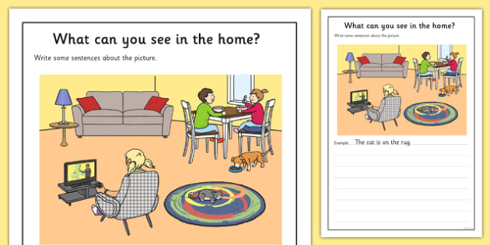

- Get your child to write some sentences to go with this picture.

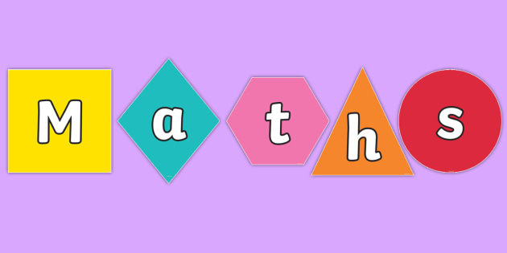

Weight
- Give your child an item e.g. an apple. Get them to find items around the house that are heavier/lighter than the apple and sort them into piles.
- Weigh an item and then see if they can use some loose parts to get to the same weight – count how many loose items they have used. Repeat several times with different items.
Extra Maths skills
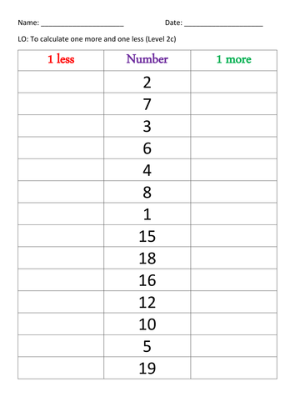

- This is just an example. Pick any numbers that your child needs to focus on.

- Recap halving, what it means. Draw a halving mat and use some loose items to half.

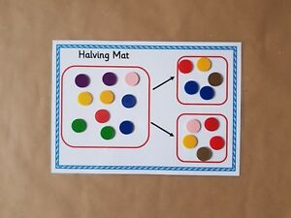

Writing:
- Read this letter from Oliver to your child

To ,
Please can you help me? My name is Oliver and I have heard that you have read the book about my Grandpa’s garden. I was so busy enjoying eating all my Grandpa’s vegetables that I have eaten them all and his garden is empty! My Grandpa says he would like me to help him plant new vegetables to grow next year. I am going shopping on Sunday to the garden centre to buy seeds, please could you write a shopping list for me to take? Thank you for your help, I will write back to you and tell you how my shopping trip was.

From Oliver xxxxx

- EXTENSION – can they write a letter to Grandpa to explain what they have decided to buy.
- Can your child draw and label a map of Grandpas new garden with all the new vegetables that have been bought?

Topic
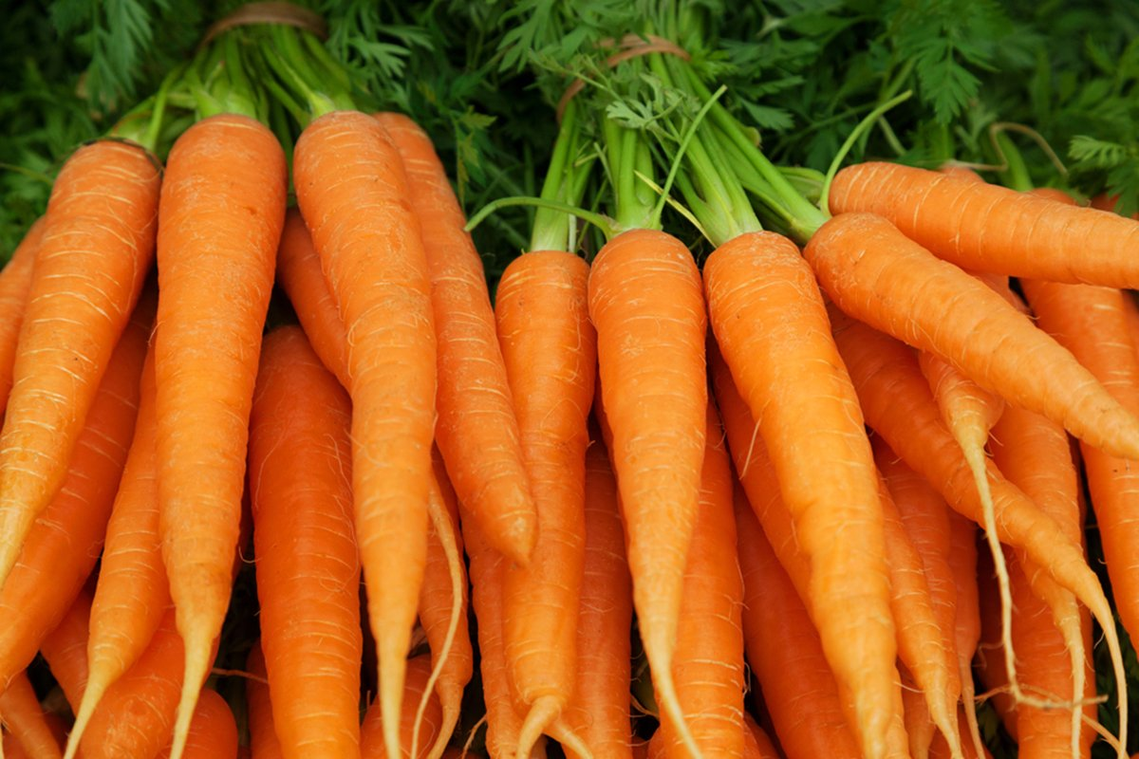

Are Carrots Orange?
- Design your own food shop. What will you sell in it? How big will it be? What will its name be? Can you label it?

- Research some tasty recipes that you can make that use carrots. Maybe have a go at making one?

- Sing and recite (maybe record and send to me) a range of food related songs - oranges and lemons, one potato two potato. Can your child sing them, add actions or props! https://www.bbc.co.uk/teach/school-radio/songs-food/zkxynrd - some ideas of songs.

- Play an ‘I went to the shop’ game in a small group where someone says a vegetable they buy from the shops and the next person has to add another item to the list and say what the previous people bought too!

- Play a listening and attention game with your child. Place a number of vegetables on a tray and cover with a blanket. Ask them to guess how many are there, then double-check by counting. Remove one of the objects - can they say which one has been removed?

