Welcome to Pine Class home learning!

Hope you had a fantastic weekend!
Remember to upload any wonderful work onto Tapestry or you can email it to us – pineclass@oakhurstfirst.com
All the best Mrs Stirk, Mrs Griffin and Mrs Kaye

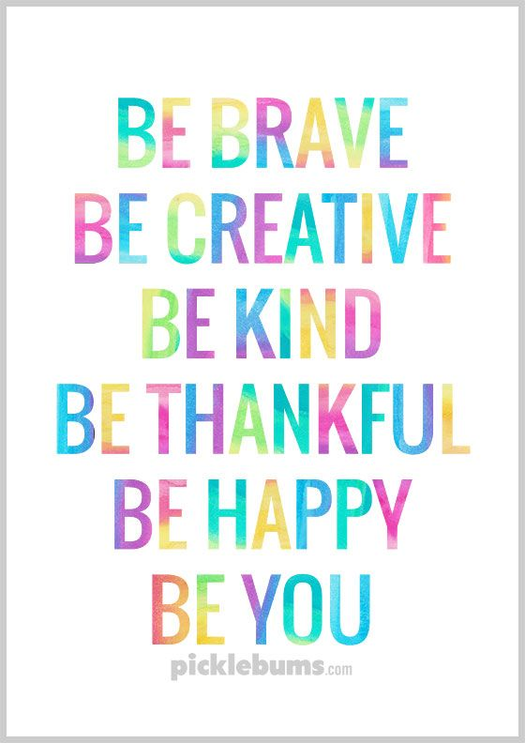

Be Active!
Start the day being active. Have a go doing any of the following…
- Cosmic Kids Yoga on YouTube
- P.E with Joe Wicks on YouTube
- Andy’s Wild Workouts on CBeebies iPlayer
- Make up a short sequence using different ways to move e.g. star jumps, hops skips,

Phonics

Please could you read your Read Write Inc PowerPoint/ditty sheet, read through the speed sounds, green words and red words on the first few slides of each PowerPoint or top of ditty sheet, then read through the book or sheet. After you have read through the story you can:
*Ask the children questions about the story.
* Choose a sentence or word from the story and get them to write it
* Practise writing/spelling any of the green or red words

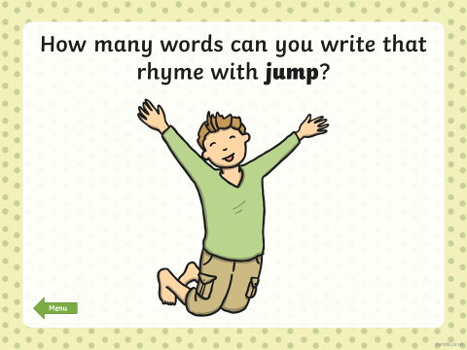

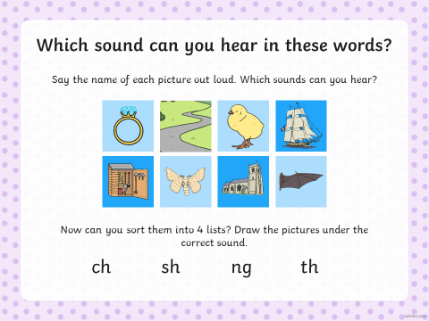

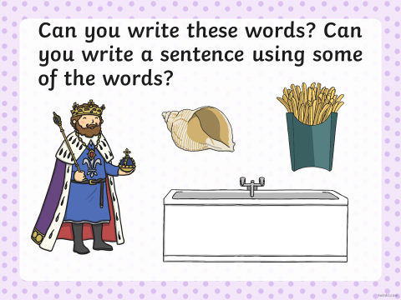

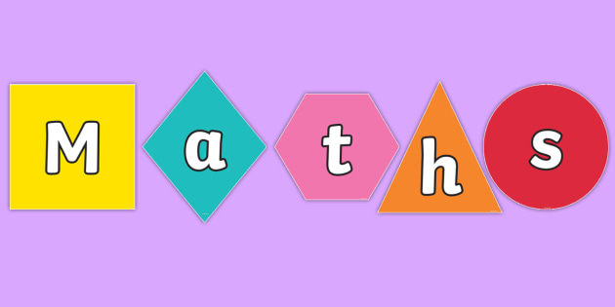

Odd and Even:
Remind your child that we are focusing on halving. Talk to them about how this is sharing something into 2. Talk about how it has to be EQUAL. Remind them that sharing in 2 is called HALVING.

- Pick an EVEN number and get your child to divide it into 2. Notice that they can share equally. Now use an odd number and repeat. Repeat several times with odd and even numbers, each time make a list of numbers that can share equally and those that don’t. Tell children that the numbers that can share equally are called EVEN numbers and those that can’t are called ODD.

- Give the children a selection of odd and even numbers for them to share by 2 in order for them to decide if they are odd or even numbers based on what you have just told them.

- https://www.youtube.com/watch?v=KEw2E1gG8Ak Watch Numberblocks (series 2 episode 11).

Extra Maths skills:
- Add 5 to each of these numbers by counting on from these numbers:
8
13
19
28
3
6

- Count in 2’s and fill in these gaps
2 __, __,__,__,__ ,__
8 __, __,__,__,__ ,__
12 __, __,__,__,__ ,__

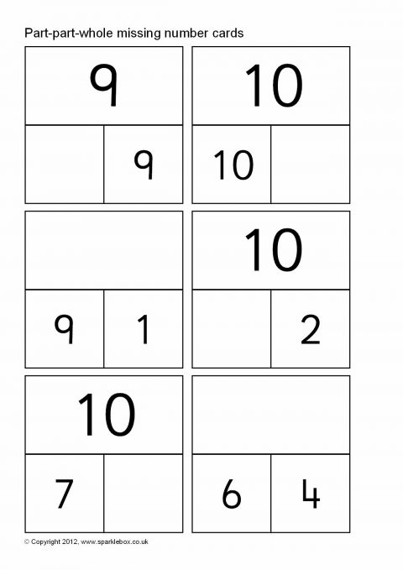
- Fill in the gaps in these part, part whole models.

Writing:

- Get your child to continue to research Africa and add to their poster. Can they make a ‘Fact box’. Can they add a picture and illustrate it. Can they draw a picture of where Africa is?

https://www.youtube.com/watch?v=PSYHMWmyVfo

https://www.bbc.co.uk/teach/class-clips-video/pshe-eyfs-ks1-go-jetters-continent-of-africa/zfv7d6f

NOTE: This is an extended piece of writing so I have allowed 2 sessions for the children to complete it (Todays and Monday 4.5.20).

REMEMBER:
- Finger spaces
- Full stop at end
- Could use a comma (will need explanation)
- Illustrate your poster

Topic
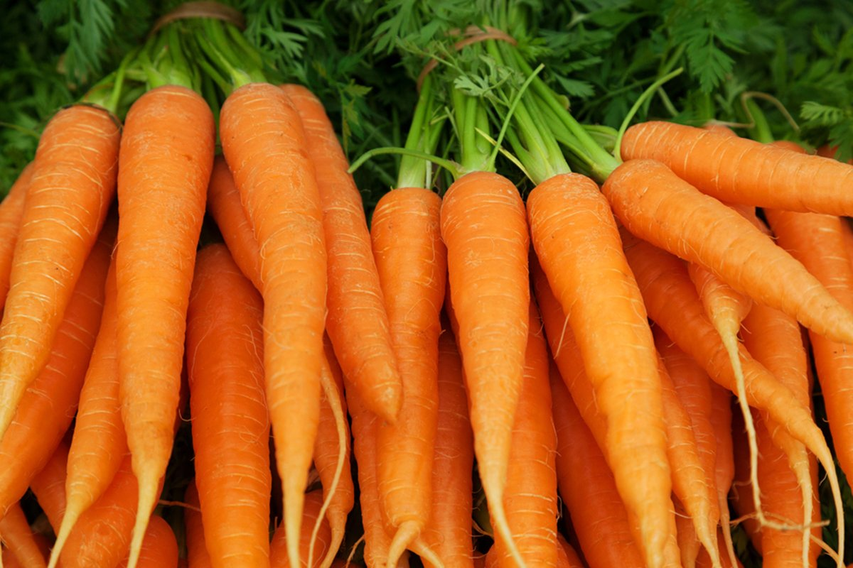

Are Carrots Orange?
- Read ‘The Very Hungry Caterpillar’, discuss the life cycle of the butterfly. Get your child to draw a simple life cycle.
- Look at pictures by William Kass – using any small figures and any fruit or vegetable get your child to make a ‘food’ themed small world. Give them a chance to play with it and discuss it with you
- Make sensory boxes using a variety of textures and smell. See if the your child can guess what it is, describe what it feels and smells like.

Discovery activity ideas:
Fine motor skills – These are activities that help your child develop their finger muscles and helps hand eye co-ordination.
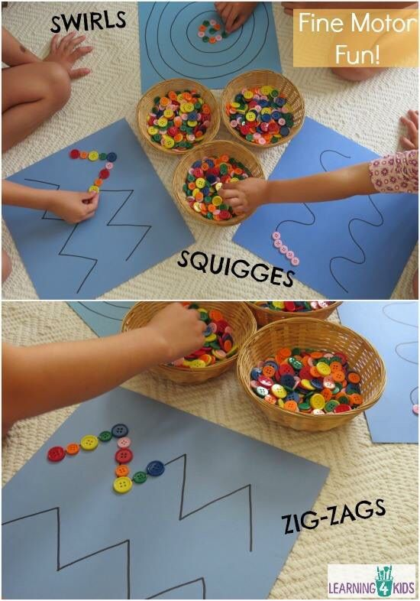
- Choose some of these activities to do over the week.

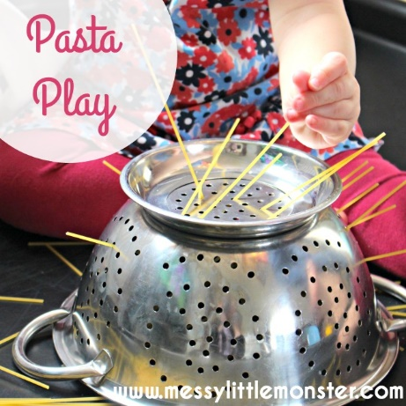
Use loose parts to create shapes and patterns. The smaller the loose parts the better.

Feed small items into small holes.

Make some playdoh and then follow ‘dough disco’ on YouTube.
https://www.youtube.com/watch?v=3K-CQrjI0uY

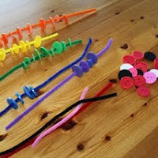
Any sort of threading is great for fine motor skills.

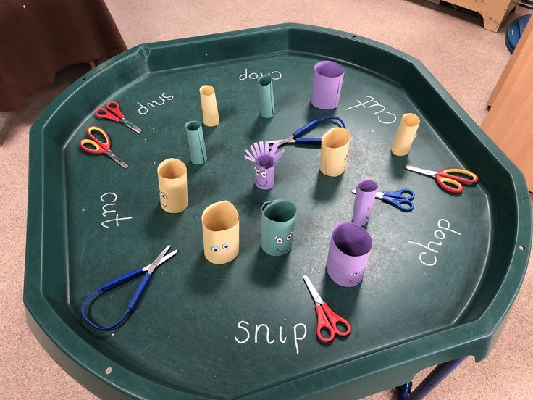
Any activities that get the children cutting are great!

