Welcome to Pine Class home learning!

Hope you had a fantastic weekend!
Remember to upload any wonderful work onto Tapestry or you can email it to us – pineclass@oakhurstfirst.com
All the best Mrs Stirk, Mrs Griffin and Mrs Kaye

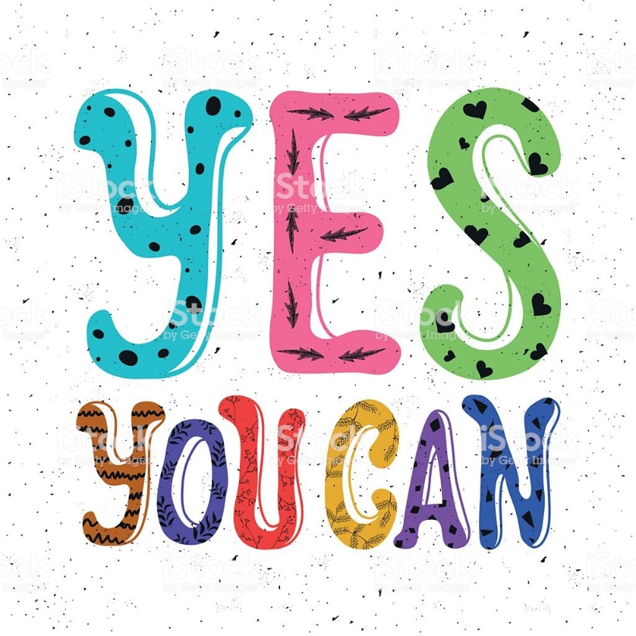

Be Active!
Start the day being active. Have a go doing any of the following…
- Cosmic Kids Yoga on YouTube
- P.E with Joe Wicks on YouTube
- Andy’s Wild Workouts on CBeebies iPlayer
- Make up a short sequence using different ways to move e.g. star jumps, hops skips,

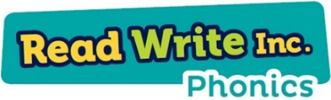
Phonics

Please could you read your Read Write Inc PowerPoint/ditty sheet, read through the speed sounds, green words and red words on the first few slides of each PowerPoint or top of ditty sheet, then read through the book or sheet. After you have read through the story you can:
*Ask the children questions about the story.
* Choose a sentence or word from the story and get them to write it
* Practise writing/spelling any of the green or red words

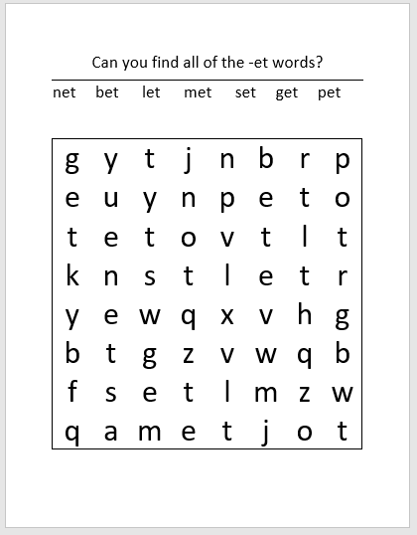

Can you make up your own word search using some other cvc words?

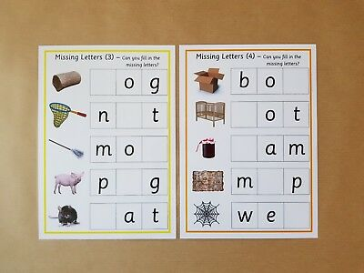

Write some words for your children, missing out some letters like above. Can they fill them in? Use sounds that they need to revise.

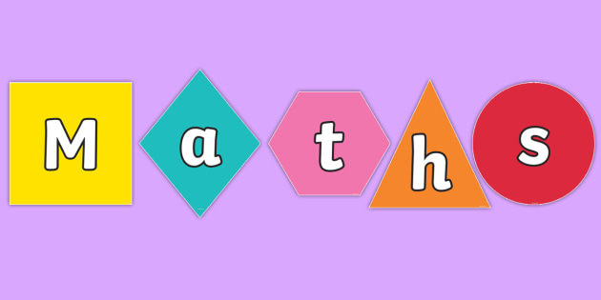

Length, height and distance:
- Go around the house and get children to identify different items to compare. Get them to use the language taller, shorter, bigger, smaller, wider, and narrower.
- Using Lego blocks or something similar get the children to measure items from around the house. How many blocks tall, wide is the item? How can they record this?
- Draw around your child’s foot, get them to compare items from around the house that is bigger, smaller than their foot.

Extra Maths skills
- Continue to work on recognise numbers 10 -20. Get your child to count backwards from 20 as well as forwards.
- Get your child to order the teen numbers.
- Play pairs with teen numbers. Get the child to name the numbers each time they turn one over.
- Recall doubles. Verbally get your child to recall their doubles.
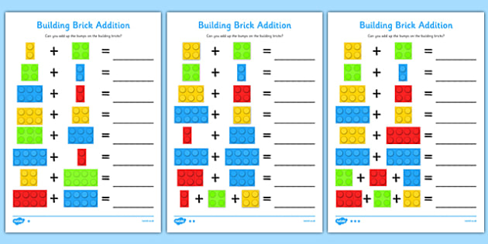

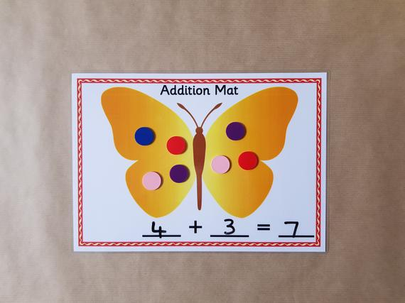
Draw some butterflies and get your child to make up some of their own addition sums.

Writing:

https://www.youtube.com/watch?v=2yvllKqyVUc Read ‘Oliver’s Vegetables’ (the sound is low, but you can read to your child).
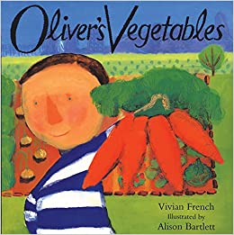

- After listening to the story get your child to draw the vegetables that they heard in the story. Get them to label the names of their vegetables.
- Give them the days of the week to match them to their pictures
- Get them to listen to story again and correct/add/change their ideas so far.
- EXTEND – children write a sentence to explain their pictures e.g. On Monday Oliver ate some carrots.

Topic
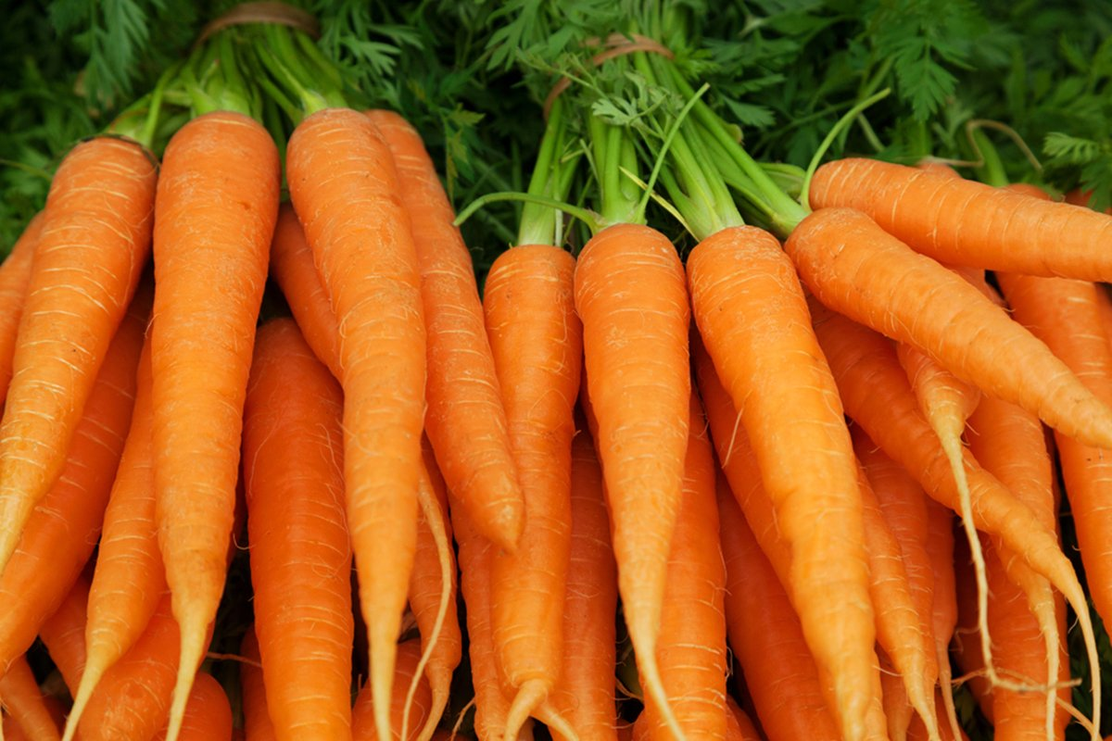

Are Carrots Orange?
- Design your own food shop. What will you sell in it? How big will it be? What will its name be? Can you label it?
- Research some tasty recipes that you can make that use carrots. Maybe have a go at making one?
- Sing and recite (maybe record and send to me) a range of food related songs - oranges and lemons, one potato two potato. Can your child sing them, add actions or props! https://www.bbc.co.uk/teach/school-radio/songs-food/zkxynrd - some ideas of songs.

