Welcome to Pine Class home learning!

This is my last home learning planning (if all goes ahead as planned for 1st June).
I would like to say a big thank you to all of you for being so supportive during this unexpected time. I have loved seeing every thing the children have been up to and really appreciate you sharing it with me.
I will continue to check my Pine Class email so please do not hesitate to get in contact if you need support with anything.

Thanks again. Take Care.
Mrs Stirk

Be Active!
Start the day being active. Have a go doing any of the following…
- Move and Freeze - https://youtu.be/388Q44ReOWE

- Disney dance – https://youtu.be/SH-7A3NVQbY

- Andy’s Wild Workouts on CBeebies iPlayer

- Kids home exercise – https://youtu.be/L-8wW40jTzc
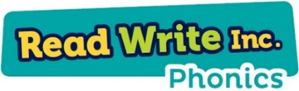
Phonics

Please could you read your Read Write Inc PowerPoint/ditty sheet, read through the speed sounds, green words and red words on the first few slides of each PowerPoint or top of ditty sheet, then read through the book or sheet. After you have read through the story you can:
*Ask the children questions about the story.
* Choose a sentence or word from the story and get them to write it
* Practise writing/spelling any of the green or red words

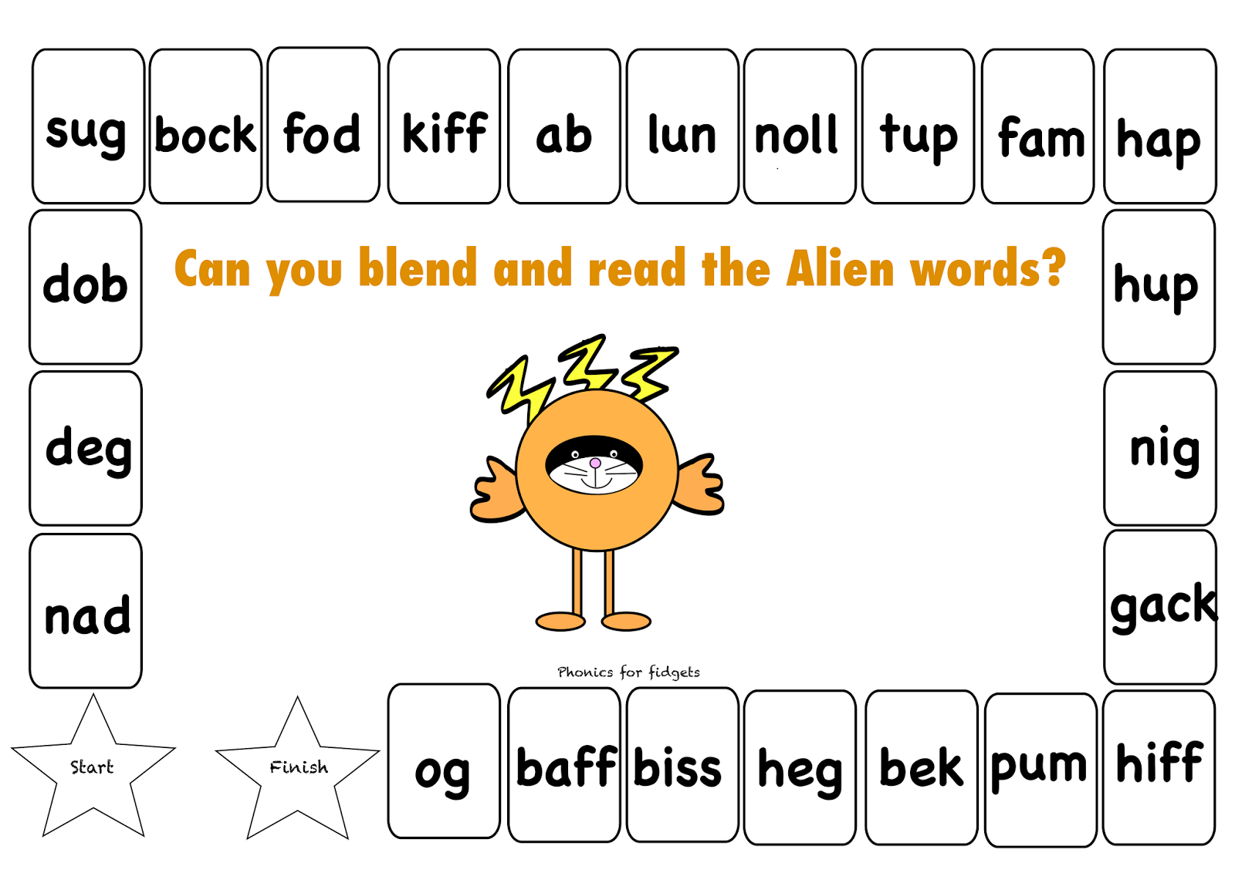

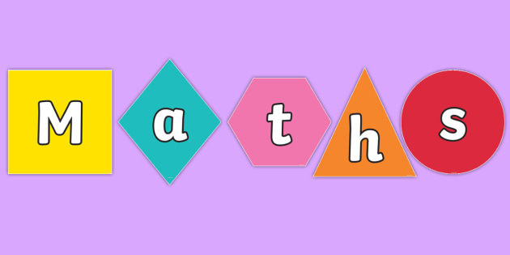

This week we will be recapping some of the areas that we have looked at already. I will put some activities each day, you can choose which areas you think your child needs to work on.
Adding and subtraction:
- Can your child use these numbers and symbols to make as many number sentences as they can:
- 4 6
- + =
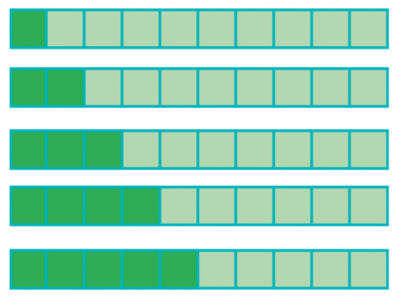
- Show your child the first of these bar models with the number sentence 1+9 = 10. Get them to make the next ones in the series.

EXTENSION – have 20 squares and get them to start with 1 +19 = 20 and continue the pattern.

One more one less

- Get your child to build a tower out of bricks, Lego or use any loose parts. Then get them make one more and one less as shown below.
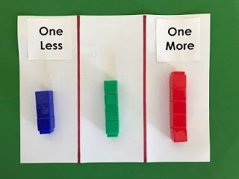

Sharing
- Remind children what sharing is, importance of being equal and fair
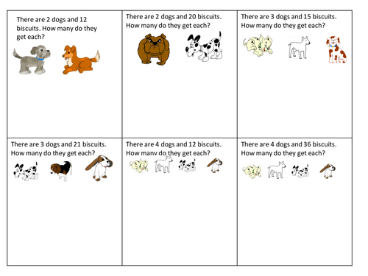
- Your child can draw their own pictures and make up their own stories to practise sharing. The ones below are just ideas.

Writing:
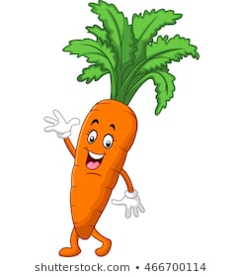

Hello I’m Caleb the carrot! I hope you have enjoyed learning all about carrots. I have always wanted to be in a story…could you write one for me? I’ve started it for you, can you finish it?

Once upon a time there lived a cheeky carrot called Caleb. One day he decided to go for a walk and …

Topic
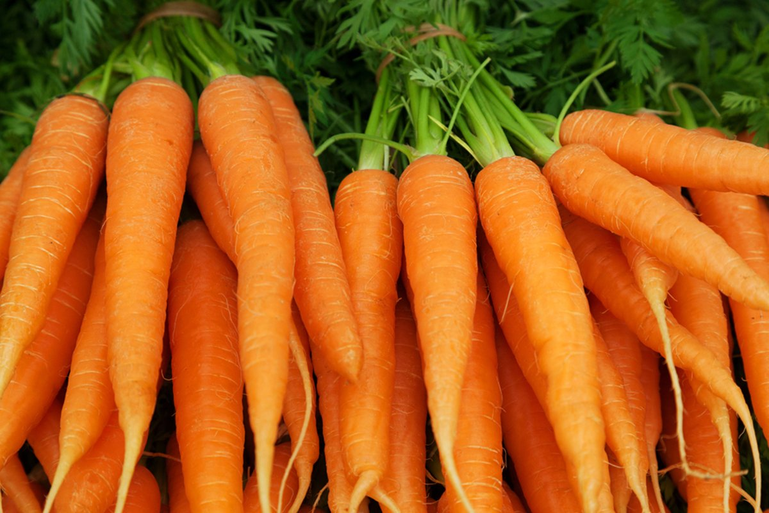

Are Carrots Orange?
- Recap healthy and unhealthy – what does this mean?
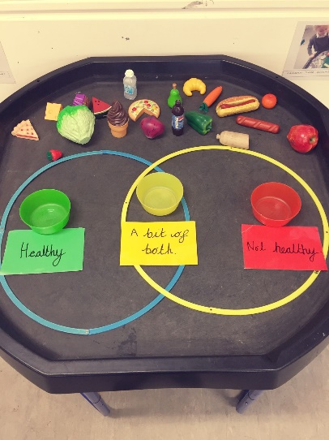
- Get your child to sort some foods, either using actual food or drawing pictures.

- Can you get your child involved in preparing a meal or a snack for your family? You could discuss how to follow a recipe, how we measure different ingredients and of course enjoy sharing the food together too! Afterwards your child could write or draw instructions to make it again.

- We have been learning about food this half term, could your child write a thank you letter to a farmer, or to the supermarket staff who work so hard to keep food on our plates, especially during this unusual time? Or perhaps they’d like to write to any other keyworkers to say thank you? We would love to see the letters but then if you are able to send the letters if appropriate.

- As our “Are Carrots orange?” topic draws to a close we would love for your child to share what their favourite things they have learnt during this period of home learning are. This could be a task set by us or perhaps a different skill that they have mastered. You could share a short video of your child talking about (or demonstrating) what they have learned, they could write a few sentences or draw a picture if they’d prefer.

