Welcome to Pine Class home learning!

Hope you had a fantastic weekend!
Remember to upload any wonderful work onto Tapestry or you can email it to us – pineclass@oakhurstfirst.com
All the best Mrs Stirk, Mrs Griffin and Mrs Kaye

Be Active!
Start the day being active. Have a go doing any of the following…
- Move and Freeze - https://youtu.be/388Q44ReOWE

- Disney dance – https://youtu.be/SH-7A3NVQbY

- Andy’s Wild Workouts on CBeebies iPlayer

- Kids home exercise – https://youtu.be/L-8wW40jTzc

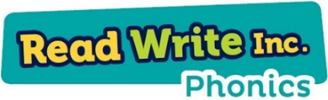
Phonics

Please could you read your Read Write Inc PowerPoint/ditty sheet, read through the speed sounds, green words and red words on the first few slides of each PowerPoint or top of ditty sheet, then read through the book or sheet. After you have read through the story you can:
*Ask the children questions about the story.
* Choose a sentence or word from the story and get them to write it
* Practise writing/spelling any of the green or red words

Recap letter names as well as sounds.
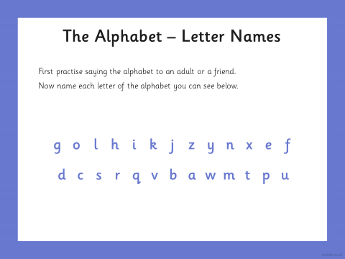
Read the words first and then add a rynming word.
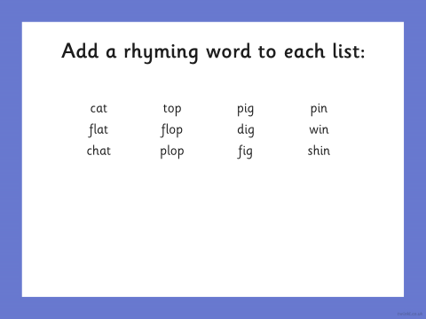

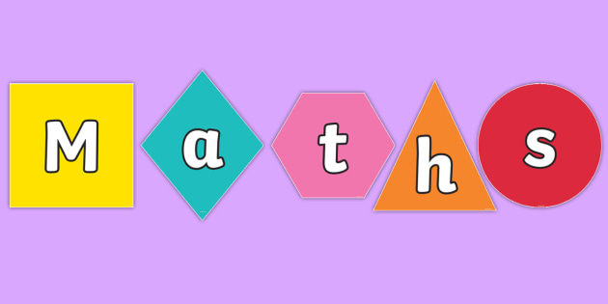

This week we will be recapping some of the areas that we have looked at already. I will put some activities each day, you can choose which areas you think your child needs to work on.
Adding:
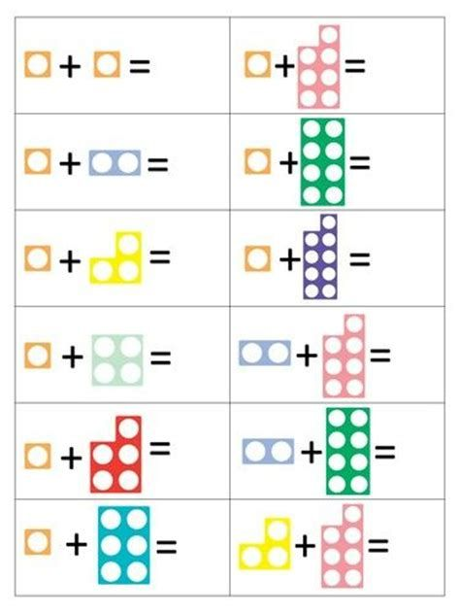
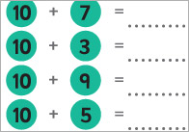

Counting Backwards from 20
- Counting backwards from 20 (make sure children correctly pronounce the teen numbers). https://www.youtube.com/watch?v=ShqXL-zfLxY

Doubling

- Recap doubling – tell this story :
Someone having trouble looking after two dogs who will not do what they are told. Then they get given two more dogs to look after - now they have four and they have ‘double trouble’! What about if they have three dogs - how many would be double trouble? Ask the children to model doubling numbers up to ﬁve on their ﬁngers and to select images to match the story numbers.
Subtraction
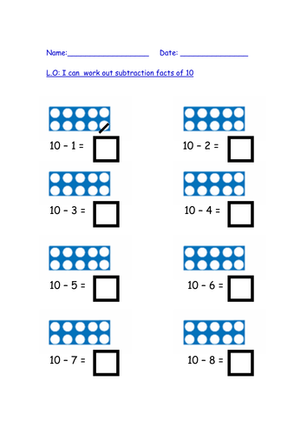

Writing:

- https://www.youtube.com/watch?v=TOGtUnrjM4A
- Watch ‘Too many carrots’.
- Discuss with your child.
- Ask your child what they would like to fill their house with, like rabbit did with carrots. As them to draw a picture and write about what they would fill it with.
E.g. I would fill my house with sausages because they are my favourite food and I would like to eat them every day.

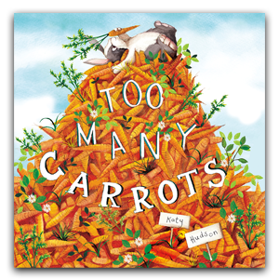

Topic
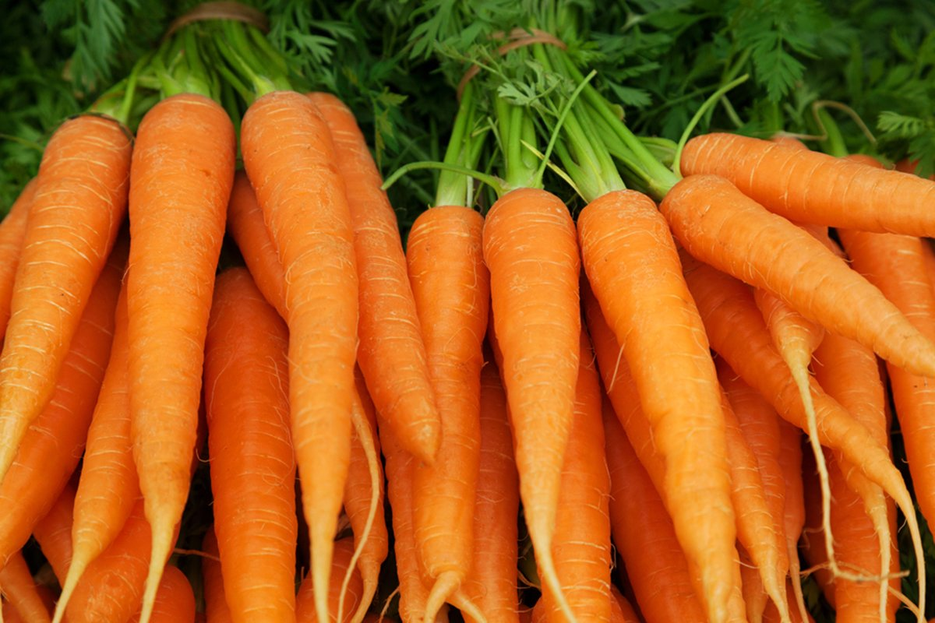

Are Carrots Orange?
- Recap healthy and unhealthy – what does this mean?
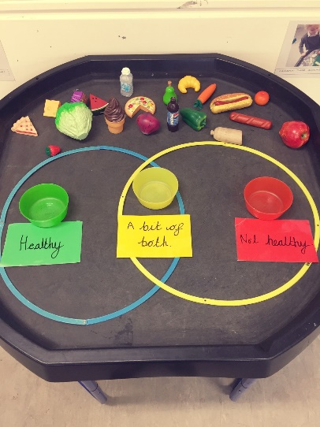
Get your child to sort some foods, either using actual food or drawing pictures.
- So…are all carrots orange? Get your child to do some research and write what they think?
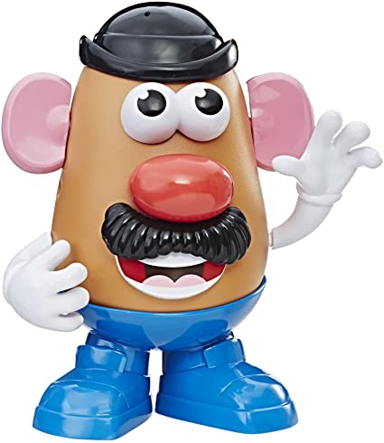
- Either provide actual carrots/potatoes or get draw an outline – get your child to make Mr Potato Head and Mrs Carrot Head!

