Welcome to Pine Class home learning!

Hope you had a fantastic weekend!
Remember to upload any wonderful work onto Tapestry or you can email it to us – pineclass@oakhurstfirst.com
All the best Mrs Stirk, Mrs Griffin and Mrs Kaye

Be Active!
Start the day being active. Have a go doing any of the following…
- Cosmic Kids Yoga on YouTube
- P.E with Joe Wicks on YouTube
- Andy’s Wild Workouts on CBeebies iPlayer
- Make up a short sequence using different ways to move e.g. star jumps, hops skips,

Phonics

Please could you read your Read Write Inc PowerPoint/ditty sheet, read through the speed sounds, green words and red words on the first few slides of each PowerPoint or top of ditty sheet, then read through the book or sheet. After you have read through the story you can:
*Ask the children questions about the story.
* Choose a sentence or word from the story and get them to write it
* Practise writing/spelling any of the green or red words

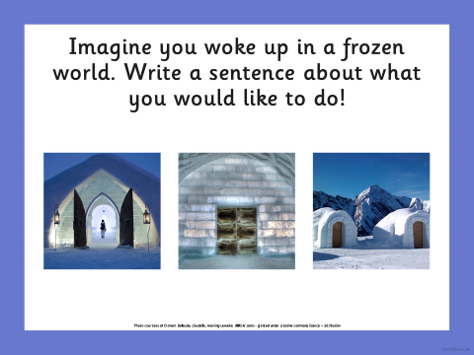

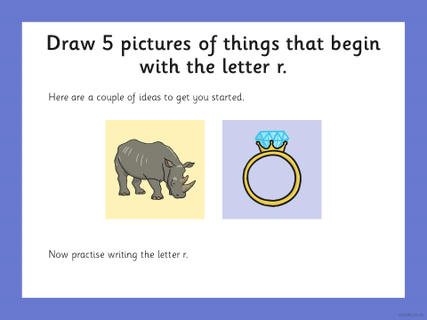

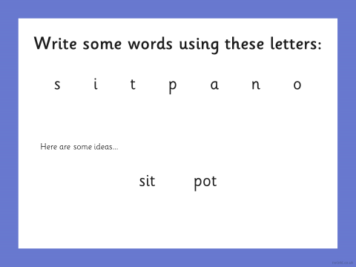

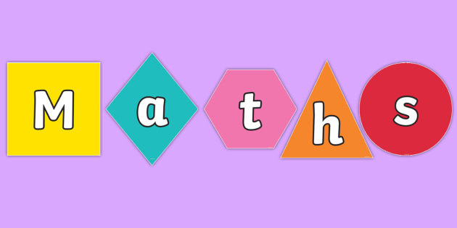

Odd and Even:
Recap what odd and even means.
- Get your child to count out a small odd number of loose items and tell you how many they have. Get them to add one more, how many do they have now? Is this number odd or even? Add one more, how many now? Odd or even? What pattern do they notice?
- Choose some of these numbers below. Get your child to count out the corresponding loose parts, share in 2 and sort if it’s odd or even. Can they draw a chart to represent this?
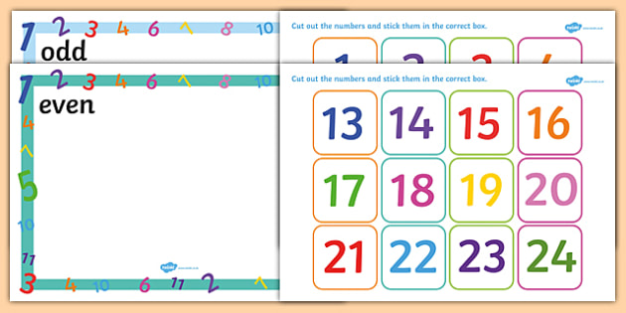

- Get your child to write the numbers 1 – 20. Use a different colour for odd and even numbers. Really focus on correct formation of the numbers.

Extra Maths skills:
- Have a go at these sharing word problems.
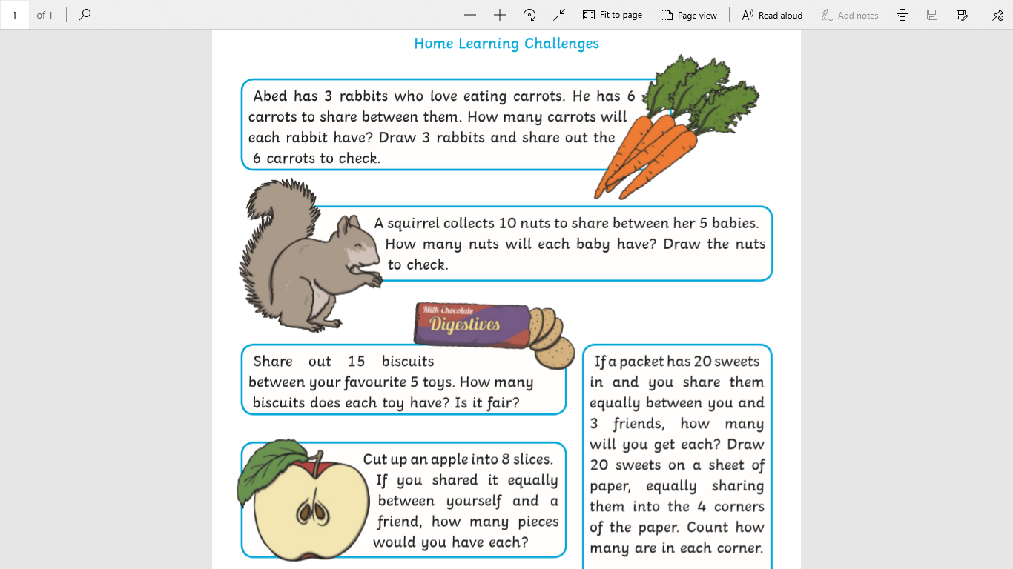

Writing:

- Remind your child of some of the animals that can be found in Africa.
- Use this website https://www.activityvillage.co.uk/african-animals to learn a bit more about the animals.
- Tell your child they are going to create their own animal. Maybe it could be half zebra and half elephant.
- Get your child to draw and label their animal. Maybe try and write a few sentences to give some more information.

THINK ABOUT:
What is its name?
What does your animal look like?
What does it eat?
How big is it?

REMEMBER:
- Finger spaces
- Full stop at end
- Accurate letter formation

Topic
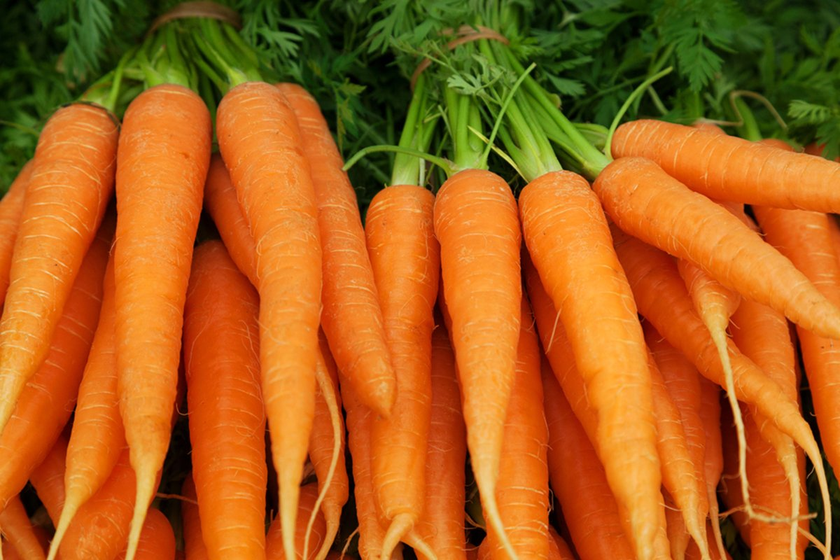

Are Carrots Orange?
- Read ‘The Very Hungry Caterpillar’, discuss the life cycle of the butterfly. Get your child to draw a simple life cycle.
- Look at pictures by William Kass – using any small figures and any fruit or vegetable get your child to make a ‘food’ themed small world. Give them a chance to play with it and discuss it with you
- Make sensory boxes using a variety of textures and smell. See if the your child can guess what it is, describe what it feels and smells like.

Discovery activity ideas:
Fine motor skills – These are activities that help your child develop their finger muscles and helps hand eye co-ordination.
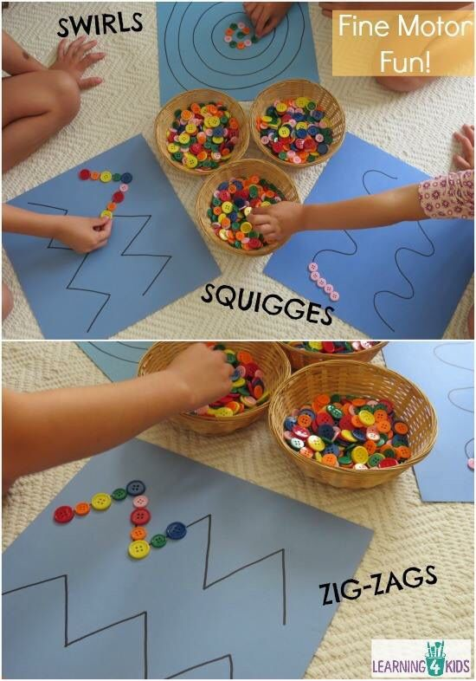
- Choose some of these activities to do over the week.

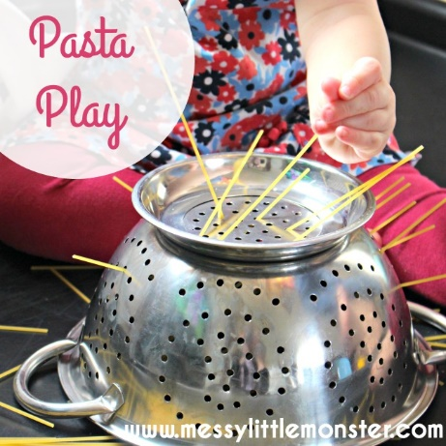
Use loose parts to create shapes and patterns. The smaller the loose parts the better.

Feed small items into small holes.

Make some playdoh and then follow ‘dough disco’ on YouTube.
https://www.youtube.com/watch?v=3K-CQrjI0uY

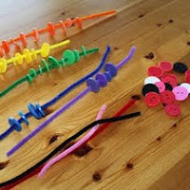
Any sort of threading is great for fine motor skills.

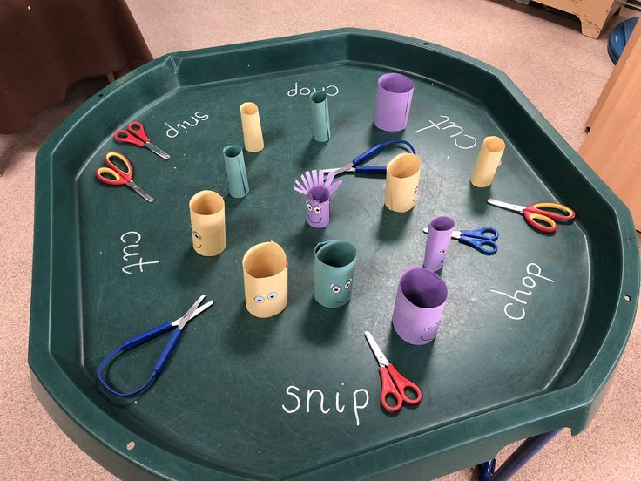
Any activities that get the children cutting are great!

